Section 1: Identification

**Product Identifier**

Windshield Washer Fluid

**Product Name**

Trade Name: OnLine +32o Windshield Washer

**Relevant identified uses of the substance or mixture and uses advised against**

Vehicle Windshield Washer Fluid

Consumer end use

**Details of the supplier of the safety data sheet**

**Manufacturer**

OnLine Packaging, Inc.

4311 Liberty Lane

Plover, WI 54467

(715)344-4861

online@onlinepackaging.org

**Emergency telephone number**

(715)344-4861

Call doctor/hospital emergency room or the Local Poison Control Center. Have the product container or label with you when calling a Poison Control Center or doctor, or when going for treatment.

Section 2: Hazard(s) Identification

**OSHA/HCS status**

This material is considered hazardous by the OSHA Hazard Communication Standard (29 CFR 1910.1200).

**Classification of the substance or mixture**

Acute toxicity, Oral Category 5 H302

Acute toxicity, Inhalation Category 5 H333

Acute toxicity, Dermal Category 5 H313

Eye Irrit. 2B H320

(STOT) – Single Exposure Category 3 H373

**GHS label elements**

**Hazard pictograms**

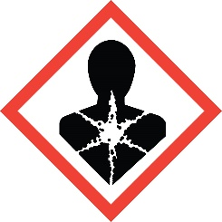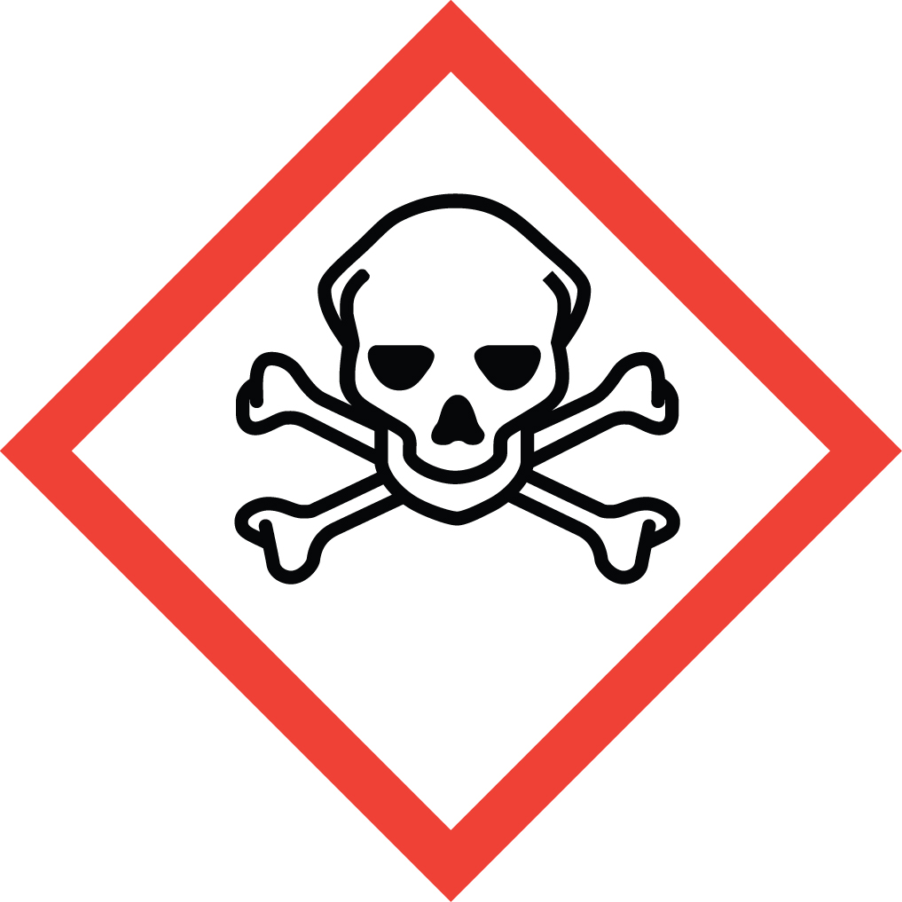

**Signal word-WARNING**

**Hazard statements**

H302 – Harmful if swallowed

H333 – May be harmful if inhaled

H313 – May be harmful in contact with skin

H320 – Causes eye irritation

H373 – May cause damage to organs through prolonged or repeated exposure

**Precautionary statements**

**PREVENTION:**

P101 – Keep out of reach of children.

P233+P234 – Keep container tightly closed. Keep only in original container.

P260+262 – Do not breathe mist, vapors’, spray. Do not get in eyes, on skin or on clothing.

P280 – Wear protective gloves, eye protection, face protection.

P264 – Wash hands and other exposed areas thoroughly after handling.

**RESPONSE:**

P301+P310 – IF SWALLOWED: Immediately call a POISON CENTER or doctor/physician.

P305+P351+P338 – IF IN EYES: Rinse cautiously with water for several minutes. Remove contact lenses, if present and easy to do. Continue rinsing.

P302+P352+P332+P313 – IF ON SKIN: Wash with soap and water. If skin irritation occurs: Get medical advice/attention.

P304+P340+P314 – IF INHALED: Remove victim to fresh air and keep at rest in a position comfortable for breathing. Get medical advice/attention if you feel unwell.

P309+P310 – If exposed or you feel unwell: Immediately call a POISON CENTER or doctor/physician.

**STORAGE:**

P403+P233 – Store in a well ventilated place. Keep container tightly closed.

**DISPOSAL:**

P501 – Dispose of contents/container in accordance with all local, state, regional and national regulations.

**Hazards not otherwise classified**

Product is stable.

Section 3: Composition/Information on Ingredients

Substance/mixture: Mixture

Chemical name: Methanol (Water and Methanol mixture)

Other means of identification: No

CAS number/other identifiers

Ingredient name % (WT.) CAS number

Methanol 1 67-56-1

Water 99 7732-18-5

Section 4: First Aid Measures

Description of necessary first aid measures

General: This product contains Methanol. Cannot be made non-poisonous. If swallowed/ingested immediately call a POISON CENTER or doctor/physician. Have the product container or label with you when calling a POISON CENTER or doctor/physician or when going for treatment.

Ingestion: If person is conscious give 1 or 2 glasses of water. Never give anything by mouth to an unconscious person. Then call POISON CENTER or doctor/physician immediately for treatment advice/method to induce vomiting. **Get** **prompt medical attention**.

Eyes: Hold eye/eyes open and rinse slowly and gently with water for 15-20 minutes. Remove contact lenses, if present, after the first 5 minutes, and then continue rinsing. Call a POISON CENTER or doctor/physician for treatment advice if irritation persists.

Skin: Take off any contaminated clothing. Immediately rinse skin with plenty of water for 15-20 minutes. If skin irritation occurs call a POISON CENTER or doctor/physician.

Inhalation: Remove person to fresh air and keep at rest in a position comfortable for breathing. Get medical advice/attention if person feels unwell.

Most important symptoms/effects, acute and delayed

**Potential acute health effects**

Ingestion: May be fatal or cause blindness if swallowed. Other symptoms include irritation of mucous membranes, nausea, headache, vomiting, dizziness, and coordination problems, blurred or snowy vision.

Eye Contact: Causes eye irritation including pain, blinking, redness and sensitivity to light.

Skin Contact: Repeated or prolonged contact can result in skin absorption which may cause irritation, itching, dermatitis.

Inhalation: Symptoms may include dizziness, headache, nausea and loss of coordination along with sore throat, shortness of breath and coughing/congestion.

**Indication of immediate medical attention and special treatment needed, if necessary**

**Notes to physician**

This product contains Methanol. Cannot be made non-poisonous and may be fatal or cause blindness if swallowed/ingested. There is a need for rapid treatment of any ingestion exposure. Over exposure may aggravate acute or chronic asthma, emphysema and bronchitis.

**Specific treatments**

N/A

**Protection of first-aiders**

N/A

**See toxicological information (Section 11)**

Section 5: Fire Fighting Measures

**Extinguishing media**

**Suitable extinguishing media**

SMALL FIRE: Use DRY chemical powder, CO2 or appropriate foam.

LARGE FIRE: Use water spray, fog or foam. Do not use water jet.

**Unsuitable extinguishing media**

None known

**Specific hazards arising from the chemical**

Vapors may travel back to ignition source. Closed containers exposed to heat may explode.

**Hazardous thermal decomposition products/Products of combustion**

Products of combustion are carbon oxides (CO, CO2).

**Special protective actions for fire fighters**

Do not release runoff from fire control methods to sewers or waterways.

**Special protective equipment for fire-fighters**

In the event of a fire, wear full protective clothing and NIOSH-approved self-contained breathing apparatus with full face piece operated in the pressure demand or other positive pressure mode.

Section 6: Accidental Release Measures

**Personal precautions, protective equipment and emergency procedures**

**For non-emergency personnel**

Ventilate area of leak or spill. Wear appropriate personal protective equipment as specified in Section 8. Isolate hazard area. Keep unnecessary and unprotected personnel from entering.

**Environmental precautions**

**Methods and materials for containment and cleaning up:**

Exposure to the spilled material may be severely irritating or toxic. Follow personal protective equipment recommendations found in Section 8 of this SDS. Personal protective equipment needs must be evaluated based on information provided on this sheet and the special circumstances created by the spill including: the material spilled, the quantity of the spill, the area in which the spill occurred, and the expertise of employees in the area responding to the spill. Never exceed any occupational exposure limits.

Prevent the spread of any spill to minimize harm to human health and the environment if safe to do so. Wear complete and proper personal protective equipment following the recommendation of Section 8 at a minimum. Dike with suitable absorbent material like granulated clay. Gather and store in a sealed container pending a waste disposal evaluation. Shut off ignition sources; including electrical equipment and flames. Do not allow smoking in the area.

Section 7: Handling and Storage

**Precautions for safe handling**

**Protective measures, advice on general occupational hygiene and conditions for safe storage, including any incompatibilities:**

Store in a well ventilated area. Keep away from heat, sparks, open flames, hot surfaces.

Keep container tightly closed. Do not breathe dust, fumes, gas, mist, vapors or spray. Wash thoroughly after handling. Do not eat, drink or smoke when using this product. Wear protective gloves, clothing, and eye and face protection. Keep container tightly closed in a cool, well-ventilated place. Keep away from oxidizing materials and strong acids.

Section 8: Exposure Controls/Personal Protection

**Control parameters**

**Occupational exposure limits**

**Ingredient name Exposure limits**

Methanol ACGIH OSHA

(TWA) (STEL) (TWA) (STEL)

200 ppm 250 ppm 200 ppm; 260 mg/m3 N/A

**Appropriate engineering controls and Environmental exposure controls**

A system of local and/or general exhaust is recommended to keep employee exposures below the Airborne Exposure Limits. Local exhaust ventilation is generally preferred because it can control the emissions of the contaminant at its source, preventing dispersion of it into the general work area. Please refer to the ACGIH document, Industrial Ventilation, A Manual of Recommended Practices, most recent edition, for details.

**Individual protection measures**

**Hygiene measures**

None

**Eye/face protection:** Use chemical safety goggles.

**Skin protection**

**Hand protection and Body protection:** Wear impervious protective clothing, including boots, gloves, lab coat, apron or coveralls, as appropriate, to prevent skin contact.

**Other skin protection**

Wash hands and other exposed areas with mild soap and water before eating or drinking.

**Respiratory protection:** No respiratory protection required under normal circumstances.

**Respirator Type(s) (NIOSH Approved):** If the exposure limit is exceeded and engineering controls are not feasible, a half face piece particulate respirator (NIOSH type N95 or better filters) may be worn for up to ten times the exposure limit or the maximum use concentration specified by the appropriate regulatory agency or respirator supplier, whichever is lowest. A full face piece particulate respirator (NIOSH type N100 filter) may be worn up to 50 times the exposure limit, or the maximum use concentration specified by the appropriate regulatory agency, or respirator supplier, whichever is lowest. If oil particles (e.g. lubricants, cutting fluids, Glycerin, etc.) are present, use a NIOSH type R or P filter. For emergencies or instances where the exposure levels are not known, use a full face piece positive-pressure, air-supplied respirator. WARNING: Air-purifying respirators do not protect workers in Oxygen-deficient atmospheres.

Section 9: Physical and Chemical Properties

**Appearance**

**Physical state:** Clear, green colored liquid

**Odor: Mild** Alcohol

**Odor threshold:** Not determined

**pH:** 8.0

**Specific Gravity:** 0.998

**Melting point:** 0oC

**Boiling point**: 98oC

**Flash point:** >55oC

**Evaporation rate** (BuAc=1): 2.1

**Flammability (solid, gas):** Yes

**Lower and upper explosive (flammable) limits:** LEL 6%, UEL 36% (for Methanol given)

**Vapor pressure:** 128 hPa at 20oC

**Vapor density (Air=1):** 1.11

**Solubility:** Soluble in water

**Partition coefficient: n-octanol/water**: Not Established

**Auto-ignition temperature:** Not Applicable

**Decomposition temperature:** Not Established

**Viscosity:** Not determined

Section 10: Stability and Reactivity

**Reactivity**

Stable under recommended storage conditions.

**Chemical stability**

Stable under recommended storage conditions.

**Possibility of hazardous reactions**

Will not occur.

**Conditions to avoid**

Temperatures above the flash point and avoid excessive heat, open flame or other sources of ignition.

**Incompatible materials**

Strong acids

Strong oxidizing agents

Strong reducing agents

Magnesium

Water-reactive materials

**Hazardous decomposition products**

Will not occur.

Section 11: Toxicological Information

**Information on toxicological effects**

**Acute toxicity**

**Product/ingredient name Test Results**

Methanol Acute toxicity, oral (male rat) LD50 = 7,300 mg/kg

Acute toxicity, dermal LD50 = 15,800 mg/kg

Acute toxicity, inhalation (rat) LC50 Rat: 87.5 mg/l 6.00 Hours

**Summary Comments:**

**Sensitization**

**Product/ingredient name Test Results Basis**

Methanol No evidence of sensitization effect

**Summary Comments:**

**Carcinogenicity**

**Product/ingredient name Test Results Basis**

Methanol No known carcinogenic effects

**Summary Comments:**

**Specific target organ toxicity (single exposure)**

**Product/ingredient name Test Results Basis**

Methanol STOT-one-time exposure-oral >5,000 mg/kg

STOT-one-time exposure-dermal >20,000 mg/kg

STOT-one-time exposure-inhalation >20,000 mg/kg

**Summary Comments:**

**Specific target organ toxicity (repeated exposure)**

**Product/ingredient name Test Results Basis**

Methanol RfD-oral 0.5 mg/kg Daily Exposure

**Summary Comments:**

Liver damage when RfD oral ingestion is exceeded daily.

**Aspiration hazard**

**Product/ingredient name Test Results Basis**

Methanol Human exposure studies Tolerance at 200 ppm/40 hours

**Summary Comments:**

**Potential acute health effects**

Ingestion: May be fatal or cause blindness if swallowed. Other symptoms include irritation of mucous membranes, nausea, headache, vomiting, dizziness, and coordination problems, blurred or snowy vision.

Eye Contact: Causes eye irritation including pain, blinking, redness and sensitivity to light.

Skin Contact: Repeated or prolonged contact can result in skin absorption which may cause irritation, itching, dermatitis.

Inhalation: Symptoms may include dizziness, headache, nausea and loss of coordination along with sore throat, shortness of breath and coughing/congestion.

**Potential chronic health effects (Methanol)**

**Carcinogenicity:** No known carcinogens.

**Mutagenicity:** No data available.

**Teratogenicity:** No data available.

**Developmental effects:** No data available.

**Fertility effects:** No data available.

**Numerical measures of toxicity**

**Acute toxicity estimates**

Toxic by inhalation, in contact with skin and if swallowed. Amounts as small as 30-250 mL of pure methanol may be fatal.

Section 12: Ecological Information

**Toxicity**

**Acute Fish toxicity: (Methanol)**

LC50 - Oncorhynchus mykiss (rainbow trout) - 19,000 mg/l - 96 h

LC50 – Lepomis macrochirus (Bluegill) - 15,400 mg/l - 96 h

**Acute toxicity for daphnia: (Methanol)**

EC50 - Daphnia magna (Water flea) - 24,500 mg/l - 48 h

EC100 - Daphnia magna (Water flea) - 10,000 mg/l - 24 h

**Acute toxicity for algae: (Methanol)**

EC50 - Scenedesmus capricornutum (fresh water algae) - 22,000 mg/l - 96 h

**Ecotoxicology Assessment: (Methanol)**

Material is expected to be slightly toxic to aquatic life.

**Persistence and degradability**

**Biodegradability: (Methanol)**

When released into the soil, this material is expected to readily biodegrade. When released into water, this material is expected to readily biodegrade. When released into the air, this material is expected to be readily degraded by reaction with photochemically produced hydroxyl radicals.

**Stability in water: (Methanol)**

When released into the water, this material is expected to have a half-life between 1 and 10 days.

**Photodegradation: (Methanol)**

No data available

**Volatility (Henry's Law constant): (Methanol)**

Partition coefficient n-octanol/water (log Kow) = -0.77

**Bioaccumulative potential**

**Bioaccumulation: (Methanol)**

Bioaccumulation Cyprinus carpio (Carp) - 72 d at 20oC

Bioconcentration factor (BCF): 1.0

**Mobility in soil: (Methanol)**

**Distribution among environmental compartments:**

When released into the soil, this material is expected to quickly evaporate. When released into the soil, this material is expected to leach into groundwater.

**Other adverse effects:**

When released into the air, this material is expected to exist in the aerosol phase with a short half-life. When released into air, this material is expected to have a half-life between 10 and 30 days. When released into the air, this material is expected to be readily removed from the atmosphere by wet deposition.

Section 13: Disposal Considerations

**Disposal methods**

Dispose in accordance with applicable international, national and local laws, ordinances and statutes.

Section 14: Transport Information

**UN Number:** N/A

**UN Proper Shipping Name:** in inner packaging not over 5L (1.3 gallons) **Limited Quantity/Consumer Commodity, ORM-D** per 49CFR 173.150 (b) (3) & 173.50 (c)

**Transport hazard Class(es):** N/A

**Packing Group:** III

Section 15: Regulatory Information

Chemical Inventory Status-Part 1

|  |  |  |  |  |
| --- | --- | --- | --- | --- |
| Ingredient (CAS#) | TSCA | EC | Japan | Australia |
| Methanol  (67-56-1) | Yes | Yes | Yes | Yes |

Federal, State & International Regulations-Part 1

|  |  |  |  |  |
| --- | --- | --- | --- | --- |
|  | SARA 302 | | SARA 313 | |
| Ingredient (CAS#) | RQ | TPQ | List Chemical | Category |
| Methanol  (67-56-1) | No | No | Yes | No |

Federal, State & International Regulations-Part 2

|  |  |  |  |
| --- | --- | --- | --- |
|  | RCRA | | TSCA |
| Ingredient (CAS#) | CERCLA | 261.33 | 8(d) |
| Methanol  (67-56-1) | 5000 lb. | U154 | No |

Chemical Weapons Convention: No

TSCA 12b: No

CDTA: No

**SARA 311/312:**

Acute: Yes, Chronic: Yes, Fire: Yes, Pressure: No, Reactivity: No

Mixture/Liquid

Australian Hazchem Code: 2PE

Poison Schedule: No information found

Section 16: Other Information

**History**

**Date of issue: 5-8-2015**

**Version: 1a**

**Revised Sections(s): New**

**Prepared by: OnLine Packaging, Inc.**

Notice to reader

To the best of our knowledge, the information contained herein is accurate. However, neither the above-named supplier, nor any of its subsidiaries, assumes any liability whatsoever for the accuracy or completeness of the information contained herein.

Final determination of the suitability of any material is the sole responsibility of the user. All materials may present unknown hazards and should be used with caution. Although certain hazards are described herein, we cannot guarantee that these are the only hazards that exist.